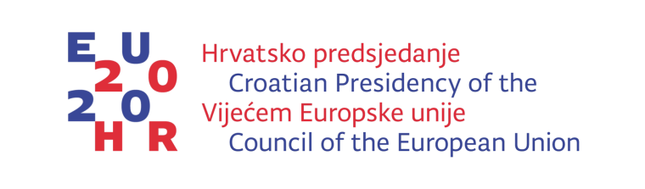
This conference is funded by the European Union’s Consumer Programme (2014-2020).

High Level Conference „Participation of women In the Labour Market – Benefit for the Society“

The High Level Conference „PARTICIPATION OF WOMEN IN THE LABOUR MARKET – BENEFIT FOR THE SOCIETY“ that will be organised by the Office for Gender Equality of the Government of the Republic of Croatia during Croatian Presidency of the Council of the European Union will take place from 30 -31, January 2020 in Zagreb.

One of the objectives of the Croatian presidency of the Council of the European Union is to boost women’s labour market participation with special emphasis on actions aiming at identifying and removing obstacles to increasing their activity rate.

The aim of the Conference is to decrease the employment gap between women and men by addressing influencing factors to women’s full participation in the labour market. The Conference will focus on specific measures that have proven to be effective in decreasing a gender employment gap, and on a possibility to strengthen monitoring and evaluation tools of implemented measures at the EU level.

The conference will gather approximately 200 participants, representatives of the EU member states, governments, academic community, EU social partners' organizations, employers’ organizations and labour unions, and NGOs who are important agents of change in the EU.
The Conference will include discussions on some of the most influential causes of women’s lower participation in the labour market, such as:
- Supply and demand of skills and occupations on the labour market from gender perspective;
- Gender dimension of non-standard, atypical employment;
- Availability, quality and affordability of home-based long term care;
- Harassment and sexual harassment in the world of work.
Specific objectives are linked to the main topics of the conference:
a) To explore effectiveness of existing measures to overcome lower participation of women in the labour market related to their skills.
b) To focus on new pathways that involve synergistic and coordinated actions of policy makers, employers’ and labour representatives to ensure equal access to quality education, training, vocational training (including apprenticeship schemes), and lifelong learning for all, including for women and men with caring responsibilities and to remove barriers that prevent participation in these activities.
c) To explore and re-address particular challenges and approaches to social and legal protection of workers in non-standard employment from gender perspective, emphasizing particularities related to gender sensitive approach to atypical work arrangements.
d) To open up a dialogue among Member States on defining a new set of comparable long - term care-related indicators that can enable comprehensive and regular review of the progress made in one of the crucial influencing factor for work-life balance.
e) To motivate the Member States to consider consolidating procedures related to combating violence, harassment and sexual harassment in the workplace, including cyber violence.
Each of the four topics will be elaborated through a theoretic approach, examples, best practices, conclusions and recommendations. EIGE’s research note on home-based long -term care that will be presented during the Conference is a valuable contribution to the Council Conclusions.

Panellists will be comprised of Croatian and international researchers, academics, officials, representatives of EU and/or UN bodies, practitioners, social partners etc.

The draft of conclusions on long-term care made during the Conference should provide input and the basis for the Council Conclusions in 2020.

